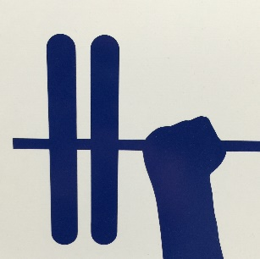
Waiver of Liability
Please read carefully. This is a release of claims and by signing I agree to the following:
- Consent to Body Connections Fitness & Massage Therapy that I am in excellent physical health and physically able to participate safely in an Exercise Program and or Workshop
- It is my understanding that at any time the Trainer can ask me to stop doing an exercise in which she feels is not appropriate for me. The Trainer reserves the right to request that I stop exercising upon observation of any symptoms of discomfort, distress, or abnormal response.
- It is my obligation to immediately inform the Trainer of any unusual pain, discomfort, fatigue, or any other symptoms that I may suffer during and immediately after physical activity.
- I have read, understood, and signed the Par-Q form
- I have my doctors consent to begin or continue with an exercise program.
- That I hereby release Body Connections Fitness & Massage Therapy, the host facility itself, plus staff, management, and any other person or persons involved in the organization and administration of the event, from any liability with respect to damage or injury that I may suffer during participation in physical activity during the program.
- I consent to having my photo taken and utilized for educational or promotional purposes. Photos or videos may be utilized online or in print.
- I understand that I will be asked to discontinue a program or workshop if the instructor feels I am at risk to myself or others. Body Connections Fitness and Massage Therapy reserves the right to limit or deny registrations for any reason.
I, the undersigned, do hereby acknowledge that I have read and understand and agree to the foregoing:
Print Name: _________________________________________

Date: _______________________________________________

Signature: ___________________________________________

Mailing Address_______________________________________

Email :_______________________________________________

Emergency Contact:____________________________________

